Tema 3

Nume: Pop Maria

Grupa: 232

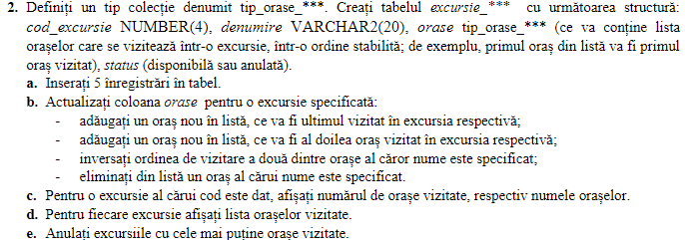

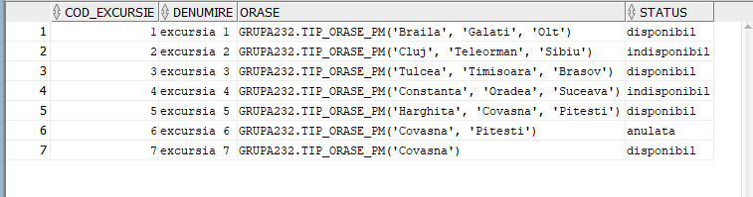

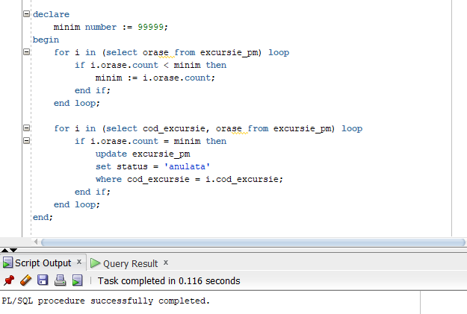

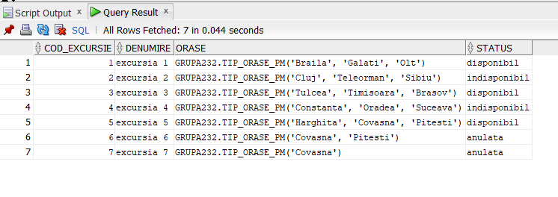



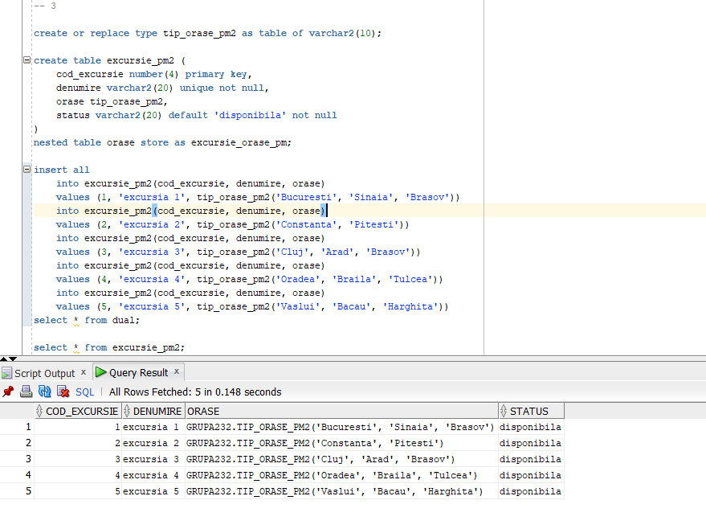

* 3. B) 1

declare

cod_excursie1 constant number not null := &cod;

orase1 tip_orase_pm2;

begin

select orase into orase1

from excursie_pm2

where cod_excursie = cod_excursie1;

orase1.extend;

orase1(orase1.count) := &oras;

update excursie_pm2

set orase = orase1

where cod_excursie = cod_excursie1;

end;

* 3. B) 2

declare

cod_excursie1 constant number not null := &cod;

orase1 tip_orase_pm2;

begin

select orase into orase1

from excursie_pm2

where cod_excursie = cod_excursie1;

orase1.extend;

for i in reverse orase1.next(2)..orase1.last loop

orase(i) := orase1(i - 1);

end loop;

orase1(2) := &oras;

update excursie_pm2

set orase = orase1

where cod_excursie = cod_excursie1;

end;

* 3. B) 3

declare

cod_excursie1 constant number not null := &cod;

orase1 tip_orase_pm2;

index1 number;

index2 number;

oras_aux varchar(20);

begin

select orase into orase1

from excursie_pm2

where cod_excursie = cod_excursie1;

for i in orase1.first..orase1.last loop

if orase1(i) = &nume1 then

index1 := i;

elsif orase1(i) = &nume2 then

index2 := i;

end if;

end loop;

oras_aux := orase1(index1);

orase1(index1) := orase1(index2);

orase1(index2) := oras_aux;

update excursie_pm2

set orase = orase1

where cod_excursie = cod_excursie1;

end;

* 3. B) 4

declare

cod_excursie1 constant number not null := &cod;

orase1 tip_orase_pm2;

index1 number := null;

begin

select orase into orase1

from excursie_pm2

where cod_excursie = cod_excursie1;

for i in orase1.first..orase1.last loop

if orase1(i) = &nume then

index1 := i;

end if;

end loop;

for i in (index1 + 1)..orase1.count loop

orase1(i - 1) := orase1(i);

end loop;

orase1.trim;

update excursie_pm2

set orase = orase1

where cod_excursie = cod_excursie1;

end;

* 3. C)

declare

cod_excursie1 constant number not null := &cod;

orase1 tip_orase_pm2;

begin

select orase into orase1

from excursie_pm2

where cod_excursie = cod_excursie1;

dbms_output.put_line('Numar orase: ' || orase1.count);

for i in 1..orase1.count loop

dbms_output.put_line('Oras ' || i || ': ' || orase1(i));

end loop;

end;

* 3. D)

declare

type tip_coduri is table of excursie_pm2.cod_excursie%type;

coduri tip_coduri;

orase1 tip_orase_pm2;

begin

for i in (select cod_excursie, orase from excursie_pm2) loop

dbms_output.put_line('Excursie ' || i.cod_excursie);

for j in 1..(i.orase.count) loop

dbms_output.put_line('Oras ' || j || ': ' || i.orase(j));

end loop;

end loop;

end;

* 3. E)

declare

minim number := 99999;

begin

for i in (select orase from excursie_pm2) loop

if i.orase.count < minim then

minim := i.orase.count;

end if;

end loop;

for i in (select cod_excursie, orase from excursie_pm2) loop

if i.orase.count = minim then

update excursie_pm2

set status = 'anulata'

where cod_excursie = i.cod_excursie;

end if;

end loop;

end;